

Virtual Health Manager

A Software Project Submitted

By

|  |  |
| --- | --- |
| Name | ID |
| **Ahmed, Ishfiaque** | 17-35236-2 |
| **Rasel,Abdulla Al Monim** | 17-34616-2 |
| **Mohammad Tawhid Gias** | 17-34470-2 |
| **Md.Rofiqul Islam** | 17-34588-2 |

Under the supervision of

**Abhijit Bhowmik**

Associate Professor & Special Assistant

Office of Student Affairs

Department of Computer Science

Faculty of Science and Technology

American International University Bangladesh

Spring Semester 2019-2020

**Disclaimer**

This is to certify that this project is our original work. No part of this has been submitted elsewhere partially or fully for the award of any other degree. Any material reproduced in this project has been properly acknowledged.

________________________________________

1. Name: Ahmed, Ishfiaque

ID No: 17-35236-2

________________________________________

2. Name: Rasel,Abdulla Al Monim

ID No: 17-34616-2

________________________________________

3. Name: Mohammad Tawhid Gias

ID No: 17-34470-2

________________________________________

4. Name: Md.Rofiqul Islam

ID No: 17-34588-2

**Approval**

The Software Project or Project titled “Intelligent Tourist Guide System” has been submitted to the following respected members of the Board of Examiners of the Faculty of Science and Technology in partial fulfillment of the requirements for the degree of Bachelor of Science in Software Engineering on 15th September 2020 by the following students and has been accepted satisfactory.

|  |  |
| --- | --- |
| ____________________________  **Abhijit Bhowmik**  Faculty& Supervisor  Department of Computer Science  American International University- Bangladesh | ____________________________  **Dr. M M Mahbubul Syeed**  Head(Undergraduate)  Department of Computer Science  American International University- Bangladesh |
| ____________________________  **Professor Dr. Tafazzal Hossain**  Dean in Charge  Faculty of Science & Technology American International University-Bangladesh | **Dr. Carmen Z. Lamagna**  Vice Chancellor  American International University-Bangladesh |

**Acknowledgements**

We would like to take the chance to express our gratitude to our honorable faculty & Supervisor Abhijit Bhowmik, for his continuous guidance and support regarding this report. Besides this, we have found so many sincere and productive advices from many people that we would like pay homage to them. We convey our gratitude to our honorable Vice Chancellor, Dr. Carmen Z. Lamagna for encouragement.

Table of Contents

**Chapter 1: Statement of Work** 7

1.1 Purpose/Objectives 7

1.2 Scope 7

1.3 Proposed System 8

1.4 System Features 9

1.5 Environment 11

1.5.1 Organizations Involved 11

1.5.2 Processing 11

1.5.3 Security 11

1.6 Assumptions 11

1.7 Constraints 11

1.8 Proposed System 12

1.8.1 Description/Improvements of Proposed System 12

1.8.2 Resources 13

1.8.3 Hardware 13

1.8.4 Software 13

1.8.5 Operating Environment 14

1.9 Project Time & Cost 14

1.9.1 Project Period 15

1.9.2 Project Schedule 16

1.9.3 Domain & Hosting Package 17

1.10 Risk assessment 18

1.11 Assessing overall project risk 21

**Chapter 2: Software Requirement Specification** 21

2.1 Objectives and Scope 21

2.2 Overview of the Present System 21

2.3 Data Flow Diagram of the Present System 22

2.4 Weakness of the Present System 22

2.5 Overview of the Proposed System 23

2.6 Benefits of Proposed System 23

2.7 System Features 23

2.8 Hardware and Software Requirements 24

2.8.2 Hardware 25

2.8.3 Software 25

2.9 Human Resource Requirements 26

2.10 Constraints and Limitations 27

2.11 Budget 28

2.12 Conclusion 29

**Chapter-3: Diagram** 30

3.1 Use Case Diagram 30

3.1.1. Admin Functionality: 30

3.1.2. Doctor Functionality: 31

3.1.3 Unregistered User: 32

3.1.4 Registered User: 33

3.2 Activity Diagram 34

3.3 Entity Relationship Diagram 35

3.4 Prototype and test images 37

**Chapter-4: Software Project Management Plan** 46

4.1 Document History and Distribution 46

4.1.1 Revision History 46

4.1.2 Distribution 46

4.2 Overview 47

4.2.1 Purpose, Objectives and Project Scope 47

4.2.2 Project Scope 47

4.2.3 Assumptions and Constraints 47

4.3 Project Deliverables 47

4.3.1 The list of project deliverables is: 48

4.3.2 Schedule and Budget Summary 48

4.4 Evolution of the Software Project Management Plan 48

4.4.1 Definitions 48

4.5 Project Organization 49

4.5.1 External Interfaces 49

4.5.2 Internal Structure 49

4.5.3 Roles and Responsibilities 49

4.6 Managerial Process Plans 50

4.6.1 Project Start-up Plan 51

4.6.2 Estimation Plan 51

4.6.3 Staffing Plan 51

4.6.4 Resource Acquisition Plan 51

4.6.5 Project Staff Training Plan 52

4.7 Work Plan 52

4.7.1 Budget Allocation 52

4.8 Control Plan 53

4.8.1 Requirements Control Plan 53

4.8.2 Schedule Control Plan 53

4.8.3 Budget Control Plan 54

4.8.4 Quality Control Plan 54

4.8.5 Reporting Plan 54

4.8.6 Metrics Collection Plan 54

4.9 Risk Management Plan 55

4.10 Closeout Plan 55

4.11 Technical process plans 55

4.12 Process Model 56

4.13 Methods, Tools and Techniques 56

4.14 Infrastructure Plan 56

4.15 Product Acceptance Plan 56

4.16 Supporting Process Plans 56

4.17 Configuration Management Plan 56

4.18 Verification And Validation Plan 57

4.19 Documentation Plan 57

4.20 Quality Assurance Plan 57

4.21 Reviews and Audits Plan 57

4.22 Problem Resolution Plan 57

4.23 Subcontractor Management Plans 57

4.24 Process Improvement Plan 58

**REFERENCES** 59

# ` **Chapter 1: Statement of Work**

## Purpose/Objectives

|  |
| --- |
| The feasibility study of this project gives an idea about the benefits that are most likely associated with it. The goal is to verify that all the resources invested in this project results in a positive outcome and that it is a successful one. |

This study makes sure that all the investments needed for this project are met and also considers the factors that are not directly related to it. The project will move on to the next step after specifying the total cost required for completion.

Feasibility study helps companies understand which projects they should develop and which ones to abandon. Although this study absorbs a small portion of the available resources, it is still a better option than investing in a project that show no sign of producing profit. Otherwise a lot of time and money will be wasted on a project that has no value.

## Scope

The scope of this project can be seen in the medical field as it can be integrated in any individual hospital. It consists of the following stages:

* Online registration procedure via web service
* Providing prescriptions to registered patients which will be automatically generated based on their provided data
* Customization of the generated prescription according to the patient’s comfort
* Online interaction between patient and doctor when needed
* Individual information module for each registered patient
* Individual information module for each doctor
* Improvement of the system of an existing hospital

The role of admin consists of updating existing system, ensuring security of data and privacy, ensuring all rules is maintained by both doctors and patients, identifying problems and finding solution for them. If there is any sort of violence or misconduct, the admin has the power of removing the accused user whether it is doctor or patient with proof of their actions.

There are two types of user which are registered and unregistered user. Unregistered users can only view the system. Registered users can book appointments with doctors according to their schedule. They will get an auto generated prescription based on the data they provide like amount of food or medicines they should consume, amount of physical exercise they should take etc. Later on they can customize the reports by consulting with their doctors as it may not be comfortable for them. They will also get more service like email and sms notification.

… [1], [2]

## 1.3 Proposed System

This software is intended to make the life of patients much easier. Patients don’t have to go through the traditional hassle of going to a hospital and booking appointment with doctors. They can easily sit at home and register online to book an appointment. They don’t even have to meet their doctors on a regular basis as they can interact online and consult their problems. They can also change their doctors if they want. The payment system is also much easier for them as it will be done through Bkash or Debit card… [6]

Below are the benefits of the system being developed:

* Online registration instead of traditional one
* No hassle for booking appointment
* Fast and safe booking
* Online payment options
* Efficient time management
* Auto generation of prescription or diet chart
* Customization of the generated report
* Online interaction instead of meeting doctors on daily basis
* Option of changing doctors if desired
* Keeping track of patient’s preference
* Schedule and appointment history
* Patient satisfaction
* Email and SMS notification updates

## 

## 1.4 System Features

The system features are as follows:

**Admin**

* Create/modify/update patient role
* Create/modify/update doctor role
* Create/modify/update content details
* Delete patient/doctor role

**Unregistered User**

* View/search contents
* Check availability of doctors and also their costs

**Registered User**

* View/search contents
* Check availability of doctors and also their costs
* Book appointment according to schedule
* Bookmark doctors
* Verify email for notification updates
* Verify mobile number for notification updates
* Start chat with appointed doctor to consult problems
* Provide data to system to get auto generated report
* Customize report by consulting with appointed doctor
* Change doctor if desired
* Give ratings

**Doctor**

* View/search contents
* View/search patients profile
* Chat with patients to consult their problem
* Check balance
* Check appointment history
* Check transaction history

**Day to Day Plan**

* Keep track of all transaction history.
* Security and authentication verification.

**Individual Patient Module**

* Check doctors profile
* Check doctors schedule
* Book appointment
* Start chat with appointed doctor
* Get auto generated report
* Change doctor
* Add doctor to favorite
* Give ratings
* Pay through Bkash or Debit card
* Check appointment history
* Check transaction history

**Individual Doctor Module**

* Check patients profile
* Chat with patients
* Check balance
* Check appointment history
* Check transaction history
* Modify report according to patients comfort

**Booking appointment**

* Viewing available doctors and their schedule
* Assigning a particular available doctor
* Different type of available doctors

**Payment**

* Keeping record of all transaction history
* Individual client wise payment module.
* Pay through Bkash or Debit card

… [7], [10]

## 

## 1.5 Environment

## 

## 1.5.1 Organizations Involved

Project Client: ABHIJIT BHOWMIK

Developer: Virtual health manager project team

User: Online users or clients

## 

## 1.5.2 Processing

* There will be a graphical user interface (GUI) for view purpose
* Any browser will be able to view the website or web application
* Three working modules are used which are admin, doctor and patient module
* There will be a single database which will store all type of information regarding patient
* The database information of the patients can be viewed by their assigned doctors
* Admin can view all type of information on the system and modify it
* Patients can view their own information as well
* The login and logout system will be completely authenticated and secure
* The data transmission for all type of users will be secure
* The records of all previous transaction are stored

## 1.5.3 Security

System’s security requirements:

* The application demands authentication from the users for access
* Registered users need to provide their email and mobile number for verification
* In case users forget their password, they can reset it after confirming their identity through verification
* Identity confirmation can be verified through the registered email address or mobile number
* Failure to login or confirm identity 5 times in a row will block the account from being logged in for a day
* Every time a user logs in from a new device, they will be sent a notification on their email or mobile

## 

## 1.6 Assumptions

For this project, web browsers like Google Chrome, Mozilla Firefox etc will be used to get access to the user interface. Third party software might also be used to develop the project. These software are open source so there is no scope for anything being illegal here. All the contents of the project are completely genuine.

The software and libraries used for this project are as follows:

* PHP ZIP files Library for compressing files
* PHP Session for user login verification
* Ajax library for dynamic interface.
* MOO tools, JavaScript, JQuery etc

## 

## 1.7 Constraints

* Usage outside regulation: For this project, the data transmission occurs through TCP/IP. Encryption services like SSL are not being used here. This might lead to some constraints regarding data passing. Problems like confidentiality and integrity might occur. Both registered and unregistered users can use the software through client application with help of internet browser on server side. In case of any missing password found by an unknown user, the responsibility goes to valid user.
* Bandwidth limitations: Server connection might be lost due to technical error. This includes both hardware and internet connection. In such cases, the query needs to be run again.
* Databases: MySQL will be used as the database software for this project. If the user queries exceed the database limitation then the database table will have to be checked again in case of lack of database caching.
* Parallel operations: If other internet applications are run along with this software then it might slow the connection speed. This might hamper the project as well.
* Language requirements: PHP will be used as the main programming language of this software. In case anyone wants to use oracle then bind technique variables will have to be used.
* Communications protocols: TCP/IP protocols will be used to communicate with the server. No other protocols are allowed even if the user wants.
* Security considerations: If users are not willing to purchase SSL security then there will be no public key encryption service for the client applications. This will lead to some problem in case of passing data.

In case of internet security, the following issues might be seen –

* **Authentication problem:** Server might not recognize valid registered users
* **Confidentiality problem:** Both user and server fail to understand the message contents
* **Integrity problem:** Server might not be able to ensure that there is no alteration of message without detection
* **Eavesdrop**: There might be intercept messages being actively inserted into the server
* **Impersonation:** There might be fake source address in packet
* **Hijacking:** The connection might be hacked by a hacker and the valid user might be replaced
* **Denial of service:** Services might be prevented from being used by others

## 1.8 Proposed System

## 1.8.1 Description/Improvements of Proposed System

* Satisfaction of patients
* Low labor cost
* Low error regarding data passing and data entry
* Authenticated transaction
* Fast paced transaction
* Efficient monitor performance
* Reduced system loading time

## 1.8.2 Resources

All the resourced that will be required for this project are given below:

## 

## 1.8.3 Hardware

Minimum requirements for server:

* Processor: Xeon based microprocessor.
* RAM: 16 GB.
* System Type: Linux (64 bit).
* Storage: 256 GB SSD.
* For Storage Service: Network File System (NFS)

Minimum requirements for client:

* Processor: Dual-core.
* RAM: 2 GB.
* System: Windows, MAC OS X, Linux.
* Web Browser: Firefox, Google Chrome, Opera etc

## 1.8.4 Software

* Notepad++
* PHP
* MySQL.
* Apache
* JavaScript

## 1.8.5 Operating Environment

The site will be hosted in a Linux server and the system will be operated from there. The hosting server will have 99% Uptime. Since this website will be browser independent so the application will be accessible through various kinds of browsers like Opera, Mozilla Firefox, and Google Chrome etc. This is a web application where the patient will have user interfaces through browser and main part is hosted on Apache Server. This site will be platform independent so the operating system can be Windows of any version starting from Windows 98 to Windows 10. MAC OS X 10.5 can also be used for this site.

## 1.9 Project Time & Cost

## 

## 1.9.1 Project Period

* The documentation of the project is expected to be completed in 4 months and the implementation is expected to take additional 4 months.

## 1.9.2Project Schedule

|  |  |
| --- | --- |
| **Term** | **Description** |
| **BA** | **Business Analyst** |
| **PM** | **Project Manager** |
| **D** | **Developer** |
| **QT** | **Quality Tester** |

The project schedule is given as follows:

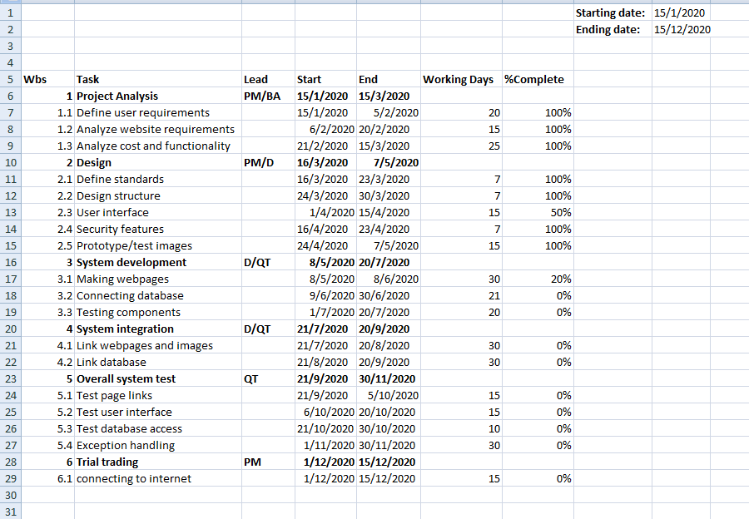

## 1.9.3Domain &Hosting Package

`w

**Domain**

* **.com** 950 tk/yr
* **.net** 950 tk/yr
* **.org** 950 tk/yr
* **.biz** 850 tk/yr
* **.info** 850 tk/yr
* **.xyz** 200 tk/yr

**Hosting Package A:** Great for small websites

* Web Space: 1GB SSD Storage
* Bandwidth: 30GB/monthly
* RAID 10 SSD Server
* Unlimited Sub Domains
* Unlimited Email Accounts
* Unlimited Databases
* Tk. 1500/Year

**Hosting Package B:** Perfect for medium sized websites

* 3GB SSD Storage
* 90 GB Bandwidth Monthly
* RAID 10 SSD Server
* LiteSpeed Web Server
* Three Addon Domains
* Unlimited Sub Domains
* Unlimited Email Accounts
* Unlimited Databases
* Tk. 2500/year

**Hosting Package C:** For the demanding sites

* 5 GB SSD Storage
* 150 GB Bandwidth Monthly
* RAID 10 SSD Server
* LiteSpeed Web Server
* Five Addon Domains
* Unlimited Sub Domains
* Unlimited Email Accounts
* Unlimited Databases
* Tk. 3500/year

**Hosting Package C:** For the highly demanding sites

* 20 GB SSD Storage
* 500 GB Bandwidth Monthly
* RAID 10 SSD Server
* LiteSpeed Web Server
* Nine Addon Domains
* Unlimited Sub Domains
* Unlimited Email Accounts
* Unlimited Databases
* Tk. 7000/year

**Estimated service cost**

|  |  |
| --- | --- |
| **Description** | **Cost Assumption** |
| Site launch (hosting) | 80,000 BDT |
| Maintenance (1 year) | 1,20,000 BDT |
| Developers | 2,00,000 BDT |
| **Grand total** | **4,00,000 BDT** |

## 1.10 Risk assessment

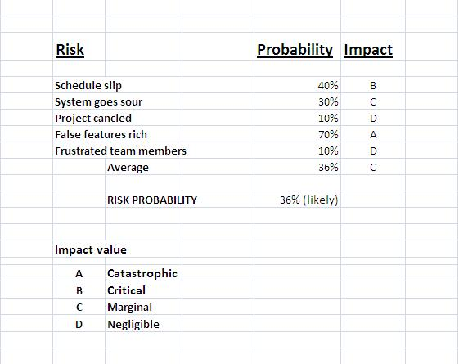

The impact of each risk driver on the risk component is divided into one of four impact categories—negligible, marginal, critical, or catastrophic.

|  |  |  |  |  |
| --- | --- | --- | --- | --- |
|  | **Catastrophic** | **Critical** | **Marginal** | **Negligible** |
|  |  |  |  |  |
| **Schedule slip** |  | Project delay, exceed budget |  |  |
| **System goes sour** |  | Unauthorized access | Communication gap between patient and doctor |  |
| **Project canceled** |  |  |  | Booking cancelation |
| **False features rich** | System doesn’t give proper output.  Unable to fulfill requirement | automatic report not generated |  |  |
| **Frustrated team members** |  |  | Fail to meet deadline |  |

… [22], [24], [26]

## 1.11 Assessing overall project risk

**1. Have software engineer team formally committed to support the project?**

**Answer:** Yes. The project is supported by all the team members. They are fully committed towards the project and they also ensure that they will give all types of available facilities.

**2. Are requirements fully understood by the software engineering team and their customers?**

**Answer:** Yes. The software engineering team has full knowledge about the project requirements so they can easily understand it. The requirements details are well organized and informative, so the customers can understand it as well.

**3. Are end-users enthusiastically committed to the project and the system/product to be built?**

**Answer:** Yes. Because the end-users are expecting the project to be built, they will be able to find all kind of information regarding Healthcare Management System.

**4. Have user been involved fully in the definition of requirements?**

**Answer:** Yes. The users have been fully involved in the definition of requirements. They are completely aware of the application requirements.

**5. Is the project scope stable?**

**Answer:** Yes. The project scope is sufficiently stable The software engineering team covers all the mandatory scope. If there is need for any other scope then it will be added to existing ones.

**6. Does the software engineering team have the right mix of skills?**

**Answer:** Yes. The software engineering team has the right mix of skills. Every team members have the capability of doing their work as a team. They also have the ability to work in pressure and have sound knowledge regarding the software implementation.

**7. Are the project requirements stable?**

**Answer:** Yes. Currently all the listed project requirements are fairly stable. Any other requirements can be added to this list later in such a way that it does not make the project unstable. All requirements for this project are easily available which will attract the end-user to use it.

**8. Does the project team have experience with the technology to be implemented?**

**Answer:** Yes. The project team has experience with the technology to be implemented because they have the sound knowledge about the technologies and the technologies are also implemented by them before.

**9. Are the project team and client aware about the possible risks?**

**Answer:** Yes. The project team and clients are aware about the possible risks related to this project. The project team has prepared the possible risk assessment and is aware of handling the risk. Clients are also notified regarding it.

# Chapter 2: Software Requirement Specification

## 2.1 Objectives and Scope

The scope of the project is to simplify the process of booking appointment with doctors and generating reports based on individual patient data. Currently there are some online hospital management systems like Square Hospital Ltd which provide the same services as our project. But these websites do not provide the scope of interacting and consulting with the appointed doctors online. There is no scope of auto generating reports based on individual patient’s data. Patients have to book appointment and visit the hospital for consulting. Our project removes all these hassles and provides an easier and smoother service.

The Virtual Health Manager System will have the following features:

* A complete list of suggested doctors based on users preferences
* Online appointment booking system based on doctors schedule
* Online interaction and consulting system between doctor and patient
* Auto generated report based on data provided by patient
* Customizable option for the auto generated reports based on patients preference
* The system lets the administrator who has the highest authority manage the users and the bookings and the content of the system.
* User can give ratings to doctors and can bookmark them as their favorite
* Online payment system through Bkash or Debit Card

… [5], [11], [12]

## 

## 2.2 Overview of the Present System

Currently there are very few system like Square Hospital Ltd implemented in Bangladesh that are based only on finding and booking appointment with doctors.

The online website of square hospital ltd lets users find doctors and book appointment on a specific branch. There is no scope of interacting and consulting with the appointed doctors online. There is no scope of auto generating reports based on individual patient’s data. Patients have to book appointment and visit the hospital for consulting… [3], [4], [7]

Our project removes all these hassles and provides an easier and smoother service.

## 

## 2.3 Data Flow Diagram of the Present System

Not required.

## 

## 2.4 Weakness of the Present System

There might be some weaknesses of the present system which are as follows:

* The list of suggested doctors might not be accurate
* Less information and availability of all kind of doctors
* The system is based on Dhaka location only
* The auto generated report might not be 100% accurate

## 2.5 Overview of the Proposed System

## 

The proposed system will allow non registered users to view the site only. If a user is registered then they will be able to check the availability of doctors and book appointments. After confirming the booking, they will be given a time schedule to interact and consult with the appointed doctor online. They will receive an auto generated report based on the data they provide like how much physical exercise they should take, what type of food and medicine they should consume etc. The patient’s can discuss with their doctor and customize the report later on according to their own comfort. They can give rating to doctors and bookmark them to their favorites. The payment system will be done online as well through Bkash or Debit Card. There is no need for any type of formal meeting here and gets rid of all the traditional hassle.

… [8], [9]

## 2.6 Benefits of Proposed System

**Benefits /Improvements of Proposed System**

* No hassle for booking appointment
* Client will define their plan and system will find the best doctors and schedules
* Online interaction system between doctor and patient
* Report auto generating option
* Report customization option
* Recommends amount of physical exercise to take
* Recommends the type of food to eat
* Recommends the type and amount of medicine to take
* Well planned budget for all appointment
* Give suggestion of doctor list to every client according to their budget
* Choices from the best doctors
* Bookmarking and rating of favorite doctors
* Fast & safe booking
* Instant transaction history
* Client satisfaction
* Compliance with time

## 

## 2.7 System Features

**Admin**

* Create/modify/update patient role
* Create/modify/update doctor role
* Create/modify/update content details
* Delete patient/doctor role

**Unregistered User**

* View/search contents
* Check availability of doctors and also their costs

**Registered User**

* View/search contents
* Check availability of doctors and also their costs
* Book appointment according to schedule
* Bookmark doctors
* Verify email for notification updates
* Verify mobile number for notification updates
* Start chat with appointed doctor to consult problems
* Provide data to system to get auto generated report
* Customize report by consulting with appointed doctor
* Change doctor if desired
* Give ratings

**Doctor**

* View/search contents
* View/search patients profile
* Chat with patients to consult their problem
* Check balance
* Check appointment history
* Check transaction history

**Day to Day Plan**

* Keep track of all transaction history.
* Security and authentication verification.

**Individual Patient Module**

* Check doctors profile
* Check doctors schedule
* Book appointment
* Start chat with appointed doctor
* Get auto generated report
* Change doctor
* Add doctor to favorite
* Give ratings
* Pay through Bkash or Debit card
* Check appointment history
* Check transaction history

**Individual Doctor Module**

* Check patients profile
* Chat with patients
* Check balance
* Check appointment history
* Check transaction history
* Modify report according to patients comfort

**Booking appointment**

* Viewing available doctors and their schedule
* Assigning a particular available doctor
* Different type of available doctors

**Payment**

* Keeping record of all transaction history
* Individual client wise payment module.
* Pay through Bkash or Debit card

## 2.8 Hardware and Software Requirements

## 2.8.2 Hardware

➢ Minimum requirements for server:

* Processor: Xeon based microprocessor.
* RAM: 16 GB.
* System Type: Linux (64 bit).
* Storage: 256 GB SSD.
* For Storage Service: Network File System (NFS)

➢ Minimum requirements for client:

* Processor: Dual-core.
* RAM: 2 GB.
* System: Windows, MAC OS X, Linux.
* Web Browser: Firefox, Google Chrome, Opera

## 2.8.3 Software

* Notepad++ / Sublime Text.
* PHP, MySQL.
* Apache

## 2.9 Human Resource Requirements

The total human resource needed for implementing and operating the system is mentioned below.

* **Hardware Specialist**: A part time hardware specialist is needed to manage all the computers of the centre. So in case of any hardware failure he/she may come and solve the problem.
* **Computer operator/Data entry operator**: A computer operator is needed to upload the online question to the system in case specific user lacks the systems know how.

## 2.10 Constraints and Limitations

**Assumptions and Dependencies**

* The users have sufficient knowledge of computers and browsers.
* The user’s computer should have Internet connection and Internet server capabilities.
* The users know the English language as the user interface will be provided in English.

**Constraints**

* Usage outside regulation: For this project, the data transmission occurs through TCP/IP. Encryption services like SSL are not being used here. This might lead to some constraints regarding data passing. Problems like confidentiality and integrity might occur. Both registered and unregistered users can use the software through client application with help of internet browser on server side. In case of any missing password found by an unknown user, the responsibility goes to valid user.
* Bandwidth limitations: Server connection might be lost due to technical error. This includes both hardware and internet connection. In such cases, the query needs to be run again.
* Databases: MySQL will be used as the database software for this project. If the user queries exceed the database limitation then the database table will have to be checked again in case of lack of database caching.
* Parallel operations: If other internet applications are run along with this software then it might slow the connection speed. This might hamper the project as well.
* Language requirements: PHP will be used as the main programming language of this software. In case anyone wants to use oracle then bind technique variables will have to be used.
* Communications protocols: TCP/IP protocols will be used to communicate with the server. No other protocols are allowed even if the user wants.
* Security considerations: If users are not willing to purchase SSL security then there will be no public key encryption service for the client applications. This will lead to some problem in case of passing data.

In case of internet security, the following issues might be seen –

* **Authentication problem:** Server might not recognize valid registered users
* **Confidentiality problem:** Both user and server fail to understand the message contents
* **Integrity problem:** Server might not be able to ensure that there is no alteration of message without detection
* **Eavesdrop**: There might be intercept messages being actively inserted into the server
* **Impersonation:** There might be fake source address in packet
* **Hijacking:** The connection might be hacked by a hacker and the valid user might be replaced
* **Denial of service:** Services might be prevented from being used by others

## 

## 2.11 Budget

|  |  |
| --- | --- |
| **Description** | **Cost Assumption** |
| Site launch (hosting) | 80,000 BDT |
| Maintenance (1 year) | 1,20,000 BDT |
| Developers | 2,00,000 BDT |
| **Grand total** | **4,00,000 BDT** |

## 2.12 Conclusion

This Requirement Specification Document has been developed based on the common healthcare scenario and previous experience of the project manager. Hence, any unexpected event or circumstances might derail the values and time frame mentioned in this document. Otherwise, the project will be documented and implemented in due time.

# Chapter-3: Diagram

## 

## 3.1 Use Case Diagram

## 3.1.1. Admin Functionality:

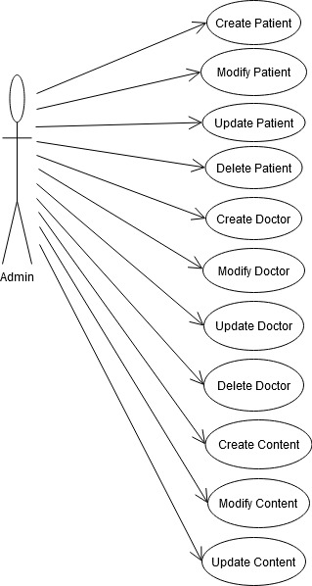

The functionality of an admin is as follows:

* Adding a new user
* Delete an existing user
* Can manage different type of users like patient, doctor
* Manage appointment schedule for the registered patients
* Update contents of doctors and patients
* Act like a staff

## 3.1.2. Doctor Functionality:

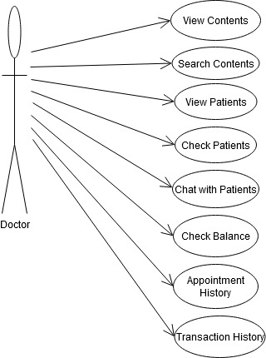

The functionality of a doctor is as follows:

* Doctors can view all type of contents within the website
* Doctors can search all type of contents within the website
* Doctors can view all type of registered patients within the website
* Doctors can chat with appointed patients within the website
* Doctors can check their balance and transaction history
* Doctors can check their appointment history with patients

## 3.1.3Unregistered User:

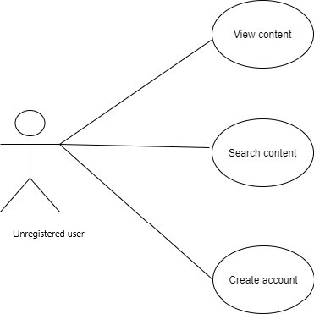

The functionality of an unregistered user is as follows:

* Create an account
* Can visit the website
* View and search contents

## 

## 3.1.4 Registered User:

**:**

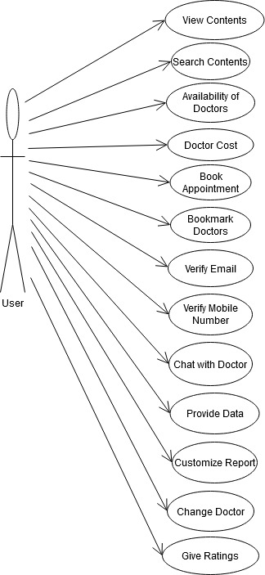

The function of a registered user is as follows:

* Create an account
* Can visit the website
* View and search contents
* Check availability of doctors
* Book appointment with doctors
* Bookmark doctors to add to their favorite
* Chat with appointed doctors
* Receive and customize auto generated reports with the help of doctors
* Give ratings to doctors after appointment is over

## 3.2 Activity Diagram

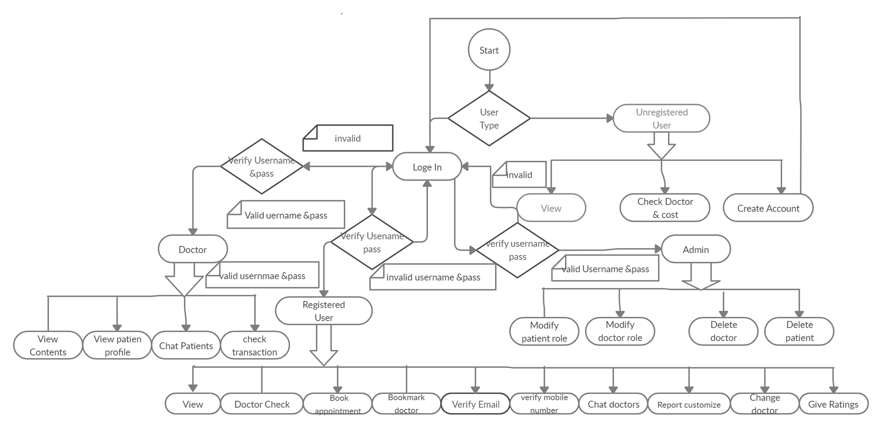

## 3.3 Entity Relationship Diagram

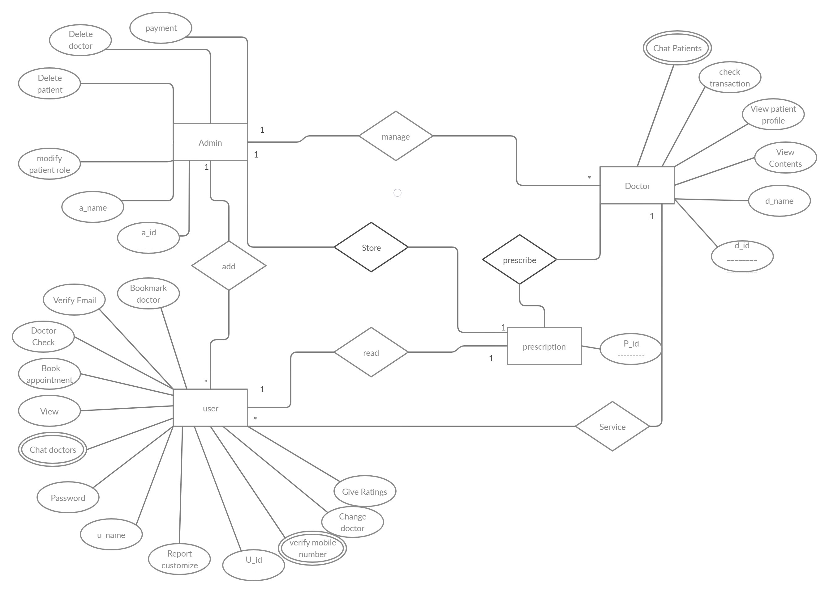

From the entity relationship diagram, the relationship among different types of users can be seen. Admin, doctor and patient all have their own attributes.

The attributes of an admin are as follows:

* Unique name
* Unique id
* Modify users role
* Delete users
* Pay doctors salary
* Provide help and support to patients

Admin can add users after they complete their registration. They also manage doctors and store prescriptions for patients which are auto-generated later on. There is one to many relationship among admin and users. The same goes for admin and doctors.

The attributes of a doctor are as follows:

* Unique name
* Unique id
* View content and patient profile
* Check transaction
* Chat with patients

Doctors prescribe and give service to their patients. There is one to many relationship among doctors and patients.

The attributes of a registered user are as follows:

* Unique name
* Unique id
* Customize report
* Appoint or change doctor
* Verify mobile number
* Verify email
* Give ratings to doctor
* Change password
* View contents
* Chat with doctors
* Check doctor schedule
* Bookmark doctor

## … [13], [14], [15], [16]

## 3.4 Prototype & test images

## 3.4.1 Prototype designs

From an admin perspective view, he/she can do the following:

* View dashboard
* Check list of available doctors
* Check list of registered patients
* Check all types of ongoing services
* View all contracts
* Search all type of contents of the website
* Pay salary of a doctor
* Logout of the system

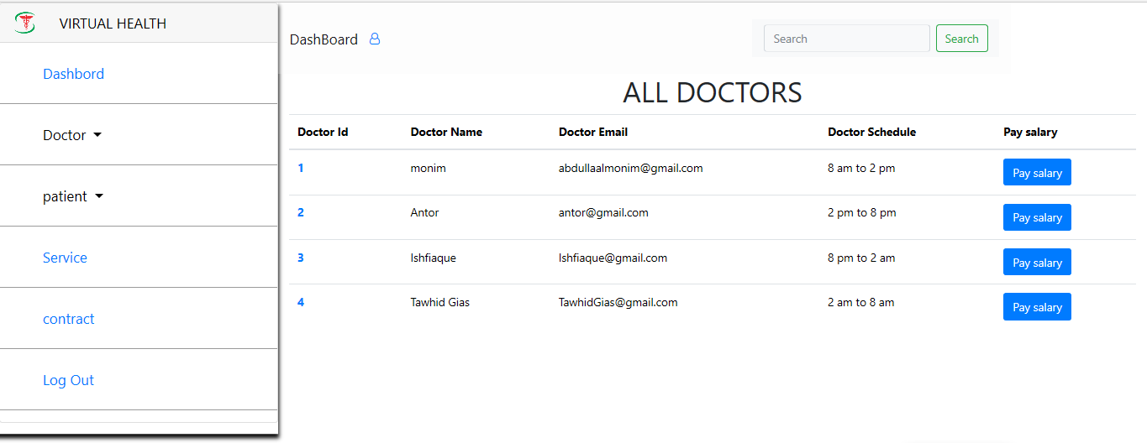

Fig 1: Admin perspective view

When a patient gets a report auto-generated by the system, he/she will get the following benefits:

* Information of appointed doctor
* Prescription number and date
* Details of prescribed medicine, food and exercise

Patients can customize the prescription later on by discussing with their appointed doctors.

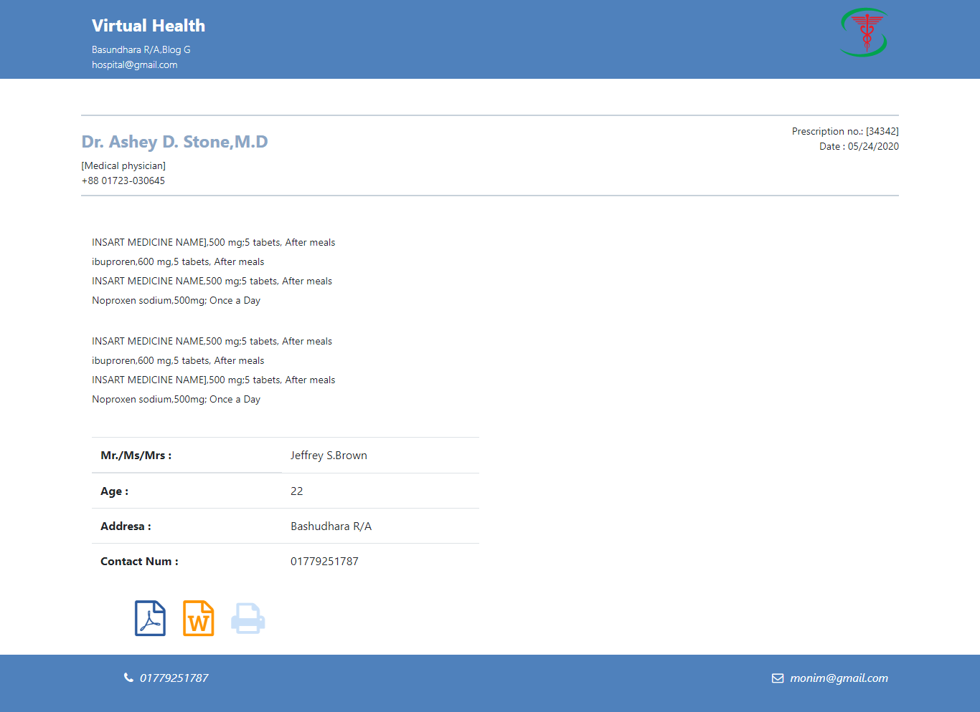

Fig 2: Patient auto-generated report

Patients can do payment through the following options:

* Bkash
* DBBL
* VisaCard

If they face any type of problem regarding payment, they can contact admin for help and support.

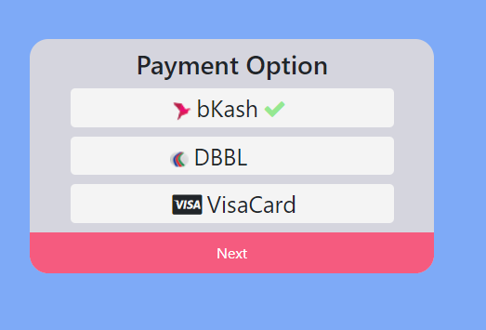

Fig 3: Payment method of patient

From a patients perspective view, he/she can do the following:

* View dashboard
* Check schedule and rating of available doctors
* Check transaction history
* Check all types of services available
* View all of their contracts
* Search all type of contents of the website
* Book appointment with a doctor
* Logout of the system

# E:\9th\sp1\test-image\patient view.png

Fig 4: Patient perspective view

## 3.4.2 Test cases

|  |  |  |  |  |  |  |
| --- | --- | --- | --- | --- | --- | --- |
| **Project Name: Virtual Health Manager** | | | | **Test Designed By: Project team members** | | |
| **Test Case ID: 01** | | | | Test Designed Date: 25 May, 2020 | | |
| **Test Priority: High** | | | | Test Executed by: Not yet | | |
| ***Module Name*: Patient signup into the system** | | | | Test Execution Deadline: 15 October, 2020 | | |
| ***Test Title*: Signup into the system** | | | |  | | |
| ***Description*: Users who are not registered into the system can signup by filling up necessary data in the registration form. Only registered users can get all the features and services of the website so signup is very crucial.** | | | |  | | |
| ***Precondition*: Unregistered users have all the required data.** | | | |  | | |
| ***Dependency*: None** | | | |  | | |
| **Test Case ID Test Steps Test Data Expected Result** | | | | **Actual Result Status** | | |
| Unreg_01 | 1.Go to the website’s signup page  2.Enter username  3. Enter password  4. Enter first name  5. Enter last name  5. Enter mobile number  6. Enter email address  7. Click Signup | Username: user11  Password: 12345  First name: Ahmed  Last name:  Ishfiaque  Mobile: 01552492335  Email: ishfiaque@gmail.com | A Congratulation message will be displayed and  Unregistered user will be registered into the system and all the information will be stored into the database for future login purpose. |  |  |  |
| Unreg_02 | 1.Go to the website’s Signup page  2.Enter username  3. Enter Password  4. Skip other info  5.Click Signup | Username: user13  Password: 56789 | An warning message will pop up requesting all necessary information to be filled out . |  |  |  |

|  |  |
| --- | --- |
| Post-Condition | **User information is stored in database and signup is successful into the system. This user can now login into the system** |

|  |  |  |  |  |  |  |
| --- | --- | --- | --- | --- | --- | --- |
| **Project Name: Virtual Health Manager** | | | | **Test Designed By: Project team members** | | |
| **Test Case ID: 02** | | | | Test Designed Date: 25 May, 2020 | | |
| **Test Priority: High** | | | | Test Executed by: Not yet | | |
| **Module Name: User login into the System** | | | | Test Execution Deadline: 15 October, 2020 | | |
| **Test Title: Login into the system** | | | |  | | |
| **Description: Registered and verified users can login in to the system without worrying about security issues** | | | |  | | |
| **Precondition: User must be registered into the system and have a valid username and password** | | | |  | | |
| **Dependency: None** | | | |  | | |
| **Test Case ID Test Steps Test Data Expected Result** | | | | **Actual Result Status** | | |
| Patient_01 | 1.Go to the website’s login page  2.Enter username  3. Enter password  4. Click login | Username: user101  Password: 14789 | User will be logged in into the website as a patient |  |  |  |
| Doctor_01 | 1.Go to the website’s login page  2.Enter username  3.Enter password  4.Click login | Username: doctor202  Password: 654321 | User will be logged in into the website as a doctor |  |  |  |
| Unreg_03 | 1.Go to the website’s login page  2.Enter username  3.Enter password  4.Click login | Username: anonymous  Password: anonymous | A login error message will be displayed stating that the provided credentials are invalid |  |  |  |

|  |  |
| --- | --- |
| Post-Condition | **User is validated with database and successfully login into the system. The account session details are logged in the database** |

|  |  |  |  |  |  |  |
| --- | --- | --- | --- | --- | --- | --- |
| **Project Name: Virtual Health Manager** | | | | **Test Designed By: Project team members** | | |
| **Test Case ID: 03** | | | | Test Designed Date: 25 May, 2020 | | |
| **Test Priority: High** | | | | Test Executed by: Not yet | | |
| **Module Name: Doctor appointment** | | | | Test Execution Deadline: 15 October, 2020 | | |
| **Test Title: Booking appointment with doctors in the website** | | | |  | | |
| **Description: Registered and verified patients need to check schedule of available doctors and book appointment with them. If a doctor is not available in that time schedule then the patient will fail to book appointment with him/her** | | | |  | | |
| **Precondition: Doctors must be available in scheduled time** | | | |  | | |
| **Dependency: None** | | | |  | | |
| **Test Case ID Test Steps Test Data Expected Result** | | | | **Actual Result Status** | | |
| Patient_01 | 1.Click on doctors option to view list of all doctors  2.Select a doctor who is available in scheduled time  3. Click on appoint option to book appointment | Doctor id  Doctor name  Doctor schedule  Doctor email  Doctor rating | A congratulations message will be displayed confirming that the appointment has been booked with the respective doctor. |  |  |  |
| Patient_02 | 1. Click on doctors option to view list of all doctors  2. Select a doctor with high rating  3. Click on appoint | Doctor name  Doctor rating | An error message will be displayed stating that the doctor is not available in scheduled time. |  |  |  |

|  |  |
| --- | --- |
| Post-Condition | **Patient books appointment with doctor in scheduled time and the record is stored in the database** |

# 

# Chapter-4: Software Project Management Plan

## 4.1 Document History and Distribution

The Virtual Health Manager is a healthcare based system where user can get appointment of all kinds of doctors. Also users can receive an auto generated report which they can customize according to their own comfort. Users will be able to save a lot of their valuable time and be benefitted from this system.

## 

## 4.1.1 Revision History

|  |  |  |  |
| --- | --- | --- | --- |
| **Revision #** | **Revision Date** | **Description of Change** | **Author** |
| 01 | March 21th , 2020 | Primary Phage | Ishfiaque Ahmed |
| 02 | March 24th , 2020 | Yes | Ishfiaque Ahmed |

These versions will show up there and also its service will be good.

## 4.1.2 Distribution

|  |  |  |
| --- | --- | --- |
| **Recipient Name** | **Recipient Organization** | **Distribution Method** |
| Abhijit Bhowmik | AIUB | Hard Copy, Soft Copy |

Soft copy and hard copy will be distributed to the recipient mentioned on the above table.

## 

## 4.2 Overview

## 4.2.1 Purpose, Objectives and Project Scope

The main purpose of this document is to develop software which will make the traditional healthcare system better. The detailed description of the both functional and non-functional requirements for this system is provided by this document. The software is developed after studying the specification and requirements of the document properly. Unless there is any unexpected event or circumstances, the final product is expected to meet the document and user requirements.

… [20], [21]

## 4.2.2 Project Scope

* To develop an online healthcare system where patients will feel easy to get appointment with doctors.
* This system makes the administrative work easy and gets rid of the traditional hassles.
* Various opportunities in one system like book appointment and get auto generated report.

## 4.2.3 Assumptions and Constraints

The assumptions during the projects are-

* The development team members do not have enough experience to complete the project as a whole
* Extra resources like people or money are not available for the project.

## 4.3 Project Deliverables

## 4.3.1 The list of project deliverables is:

1. Statement of Work (SOW)
2. Software Requirements Specification (SRS)
3. Software Project Management plan (SPMP)
4. Software Design Plan (SDP)

## 

## 4.3.2 Schedule and Budget Summary

|  |  |
| --- | --- |
| **Schedule** | |
| **Milestone or Major Project Deliverable** | **Planned Completion Date(Day)** |
| SOW | September 15th , 2020 |
| SRS | September 30th , 2020 |
| SPMP | October 10th , 2020 |
| SDP | October 20th , 2020 |
| Software testing plan | November 7th , 2020 |
| Presentation & project progress | November 25th , 2020 |
| Technical documentation | With completed product |
| Software evaluation report | Along with final submission |

## 4.4 Evolution of the Software Project Management Plan

The preliminary drafts of the SPMP will be submitted to the project manager and after approval; copies of the same will be distributed to the members of the group on the date as referred to in section 1.1.4.

## 4.4.1 Definitions

|  |  |
| --- | --- |
| **Terms** | **Description** |
| 1. SOW | Statement of Work |
| 1. SRS | Software Requirement Specification |
| 1. SPMP | Software Project Management Plan |
| 1. SDP | Software Design Plan |
| 1. SQATP | Software Quality Assurance and Testing Plan |
| 1. Impact | 1-catastrophic  2-critical  3-marginal  4-negligible |

## 4.5 Project Organization

The organization of a project depends on three main structures which are as follows:

## 4.5.1 External Interfaces

The external interface is where the interaction between development team and customers take place. All required communication will be done through anyone on the team, but all discussions with the user will be documented clearly for keeping record. If user demands for any change in service or configuration then the request needs to be made in written form. The form needs to be also approved by the project’s Configuration Control Board (CCB), which consists of all team members.

## 4.5.2Internal Structure

This project has four developers and each member has their own specified area of work. Everyone is committed towards the project and contributes equally for completing it. Since the number of members is limited, all the works are shared throughout the duration of the project documentation and implementation. Each member will have more than role and will keep changing roles through the duration of the project.

## 4.5.3 Roles and Responsibilities

Each member of the development team is responsible for all documentation, implementation and development of this project.

## 4.6 Managerial Process Plans

## 

## 4.6.1 Project Start-up Plan

This section describes all the necessary materials and resources required to start the project. Since most of these information were pre-defined for the team, this section will not describe the rationale for many of these choices.

## 

## 4.6.2 Estimation Plan

The total time for documentation, developing and implementing this project is expected to be 1 year and the total cost to be 2,00,000 BDT. These numbers were estimated through expert judgment and by comparing with similar type of projects.

## 4.6.3 Staffing Plan

Each team member will be available for 9 hours per day as the project purpose. During this time team meetings, supervisor meetings, document preparation, document inspection and tool development will take place.

## 4.6.4 Resource Acquisition Plan

* All resources for this project will be available at the start of documentation phase
* There is no chance of any resource being decayed over time as they are limited
* The technical writer can change the resources after documentation is completed
* The team member’s roles will change according to project needs

## 4.6.5 Project Staff Training Plan

For this project, the staffs do not require any kind of extra training.

## 4.7 Work Plan

This part includes all work activities and allocation of budget.

… [23], [25], [27]

## 

## 4.7.1 Budget Allocation

|  |  |  |
| --- | --- | --- |
| Budget Allocation | | |
|  | **Hours** | **Costs** |
| **Agency Labor** | 500 | 6,00,000 BDT |
| **Contract Labor** | 720 | 4,00,000 BDT |
| **Non-Labor Costs** | 800 | 10,00,000 BDT |
| **Total Hours / Implementation Cost** | 2020 | 20,00,000 BDT |

## 4.8 Control Plan

## 4.8.1 Requirements Control Plan

If any changes need to be made in the requirements after the release of Software Requirement Specification then they have to be brought to the attention of the developers and discussed. The supervisor needs to give approval to any kind of changes that needs to be made. Moreover these changes can be done only if feasible and permissible within the constraints of the project and resources in terms of knowledge and skill of the developers required. An update version of the SRS document will be released after the changes are made.

## 4.8.2 Schedule Control Plan

If there is any delay in work schedule that is planned then the developer will have to spend extra time on the project. This can be done in between and after the schedules to make up for the lost time. The project needs to completed in due time whatever the events and circumstances.

## 4.8.3 Budget Control Plan

The average monthly income will be determined by summing up all earnings for the year and dividing the total by 12. The average monthly spending will be generated by tracking all expenditures. Savings is calculated through the difference between "Budget" and "Current Spending”. If expenditure exceeds the income then some expenditure needs to be cut depending on the specific savings goals. The project manager monitors the expenses of the project. This is also reported and can be accessed via the Weekly Status Report.

## 4.8.4Quality Control Plan

If there any is major change that will affect any milestone or the budget then they have to approve by all team members. Each member will be responsible for ensuring that the project is completed in due time and within budget. There will be regular meetings between supervisor and team members. At each meeting, developer team will present the day’s progress and problems. The supervisor will determine whether they are progressing as expected and whether they are following the specification document and the project management plan. Any major problems faced by the team members will immediately be reported to the supervisor and discussed to solve the problem.

## 4.8.5 Reporting Plan

As previously mentioned in section 1.1.4 the Software Project Management Plan will be completed and update with all the required changes. Every older version of changes and report will be sent to the project manager. After getting approval from him, the updated reports will be sent back to the project team members and they will continue work to complete the project.

## 4.8.6 Metrics Collection Plan

As the system based on object oriented so the metrics focus on measurement that can be applied to the class and the design characteristics—localization, encapsulation, information hiding, inheritance, and object abstraction techniques—that make the class unique.

## 4.9 Risk Management Plan

The risk management plan is as follows:

|  |  |  |  |  |
| --- | --- | --- | --- | --- |
| **Risks** | **Probability** | **Impact** | **Rating** | **RMMM** |
| Project Manager Availability | 50% | 3 | Medium | R-1 |
| Schedule slips | 70% | 1 | High | R-2 |
| System goes hour | 60% | 3 | Medium | R-3 |
| Project canceled | 30% | 4 | Low | R-4 |
| False feature rich | 40% | 2 | Low | R-5 |
| Programmers doesn’t have good experience | 50% | 3 | Medium | R-6 |
| Late delivery | 50% | 3 | Medium | R-7 |
| Customer Participation in Beta Testing | 30% | 4 | Low | R-8 |

… [22], [24], [26]

## 4.10 Closeout Plan

When the project will be close to being completed, the following actions will take place:

* The developer team will make a hard copy file of all documents, source code, plans, etc. generated by the team.
* The developer team will also copy all materials in electronic format on a CD-ROM.

## 4.11 Technical process plans

The development process model, technical models, tools and techniques that will be used to develop the work products, project infrastructure and product acceptance plan will be specified by the Software Project Management Plan.

## 

## 4.12 Process Model

During the project implementation, the XP (extreme Programming) agile process model will be followed

## 4.13 Methods, Tools and Techniques

The project adapts the system on Personal Computer using HTML, PHP, Apache, Notepad++, XAMPP, Visual Studio 2012 and MySQL for database management system.

## 

## 4.14 Infrastructure Plan

The hardware resources are three Intel Core2Duo Personal Computers running Window XP/Vista or UBUNTU operating system. The project using software resources are like Notepad ++, Adobe Dreamweaver, Adobe Photoshop, Adobe Flash, XAMPP, Wamp etc.

## 4.15 Product Acceptance Plan

The project manager will approve each milestone completed and give authorized signature as a sign of completion of milestone. An acceptance test will be performed by the project manager at the end of every phase. This might lead to additional requests for change and improvements. The final product will be tested by the project manager and if it meets all the required requirements then it will be accepted.

## 4.16 Supporting Process Plans

The plans for the supporting processes that are part of the software project will be included by the Software Project Management Plan. These are configuration management plan, verification and validation, software documentation, quality assurance, reviews and audits, problem resolution and subcontractor management.

## 4.17 Configuration Management Plan

Project deliverables are usually considered to be configuration items of the project. These items are named properly after its document following their individual version number. For example, all the older files that are sent to the project manager will be named with their individual abbreviation followed by numbers like 0.1, 0.2 etc. After getting approval from the project manager, the name of the document will be changed to 1. This document will be distributed to each project member. In case of any informal updates with the project manager, it will be numbered with 1.1, 1.2 etc. and the next full distribution to the committee would be version 2.0 etc.

## 4.18 Verification and Validation Plan

The Software Project Management Plan for this project shall contain the verification and validation plan for the software project and it shall include tools, techniques and responsibilities for the verification and validation work activities. There will be a separate document for the verification and validation plan. This document will be maintained properly.

## 

## 4.19 Documentation Plan

All kinds of documentation needs to follow the IEEE standards. All the documents would be discussed and reviewed with project manager before their baseline versions are issued and distributed to the members of the committee on the due dates.

… [28]

## 

## 4.20 Quality Assurance Plan

The project manager will check the quality of the project and inform the team members about it. He will also give suggestion for maintaining the quality of the project.

## 4.21 Reviews and Audits Plan

Review and Audits would be addressed as a part of the Software Quality Assurance and Verification & Validation Plan that would be developed following recommended departmental standards.

## 4.22 Problem Resolution Plan

The project manager and developers will solve all problems of the project informally. That is, there is no specific plan. If there is need for such a plan then the Software Project Management Plan will be updated accordingly.

… [29]

## 4.23 Subcontractor Management Plans

Subcontractors are people who can contribute work products to the software project. But this project does not involve managing any subcontractor.

## 

## 4.24 Process Improvement Plan

When the documentation of the project is completed and the implementation work is in progress, the project manager will regularly check the status of the project. He will inform the project team members if there is any need for any kind of change for improvement.

## … [30]

## REFERENCES

1. <https://www.squarehospital.com/appointment>
2. <https://www.e-hospitalservices.com/>
3. <https://www.apollodhaka.com/>
4. <http://103.247.238.81/hsmdghs/registration/index.php>
5. <https://ors.gov.in/index.html>
6. <https://www.ncbi.nlm.nih.gov/pmc/articles/PMC6352157/>
7. <http://www.yourarticlelibrary.com/india-2/rural-development/project-meaning-features-and-categories/66728>
8. <https://solutiondots.com/blog/features-hospital-management-system-developed-solutiondots-systems/>
9. <https://existek.com/blog/hospital-managment-system/>
10. <https://www.quora.com/What-are-the-main-features-of-a-Hospital-Management-System-and-what-are-the-extra-features>
11. <https://onlinemedicalcare.org/best-online-doctor-medical-services/>
12. <https://www.osplabs.com/hospital-management-system/>
13. http://www.omg.org/technology/documents/formal/uml.htm
14. <https://www.guru99.com/dbms-schemas.html>
15. http://www.oscommerce.com/solutions/documentation
16. [Boo91] G. Booch, Object-oriented design with applications, Benjamin/Cummings, 1991.
17. [Bru95] G. Bruno, Model-based software engineering, Chapman & Hall, 1995.
18. [Cut05] Cutter Consortium, Software project success and failure,
19. <http://cag.gov.in/AMS-URS-Comments.pdf>
20. <http://www.aspera-3.org/idfs/APAF_SRS_V1.0.pdf>.
21. <http://www.stellman-greene.com/aspm/>
22. <http://en.wikipedia.org/wiki/Risk_management>
23. <http://en.wikipedia.org/wiki/Software_project_management>
24. [www.theirm.org/publications/documents/Risk_Management_Standard_030820.pdf](http://www.theirm.org/publications/documents/Risk_Management_Standard_030820.pdf)
25. <https://www.cfainstitute.org/en/research/foundation/2011>
26. <https://www.phe.gov/about/amcg/contracts/Documents/risk-management.pdf>
27. <https://en.wikipedia.org/wiki/Risk_management_plan>
28. <http://alexandre-plennevaux.infographie-heaj.eu/e-book%20collection/The%20Principles%20Of%20Project%20Management.pdf>
29. <https://bookboon.com/en/project-management-ebooks>
30. <https://epdf.tips/project-management.html>